**Aviva Test Assignment Execution Report Document:**

**Aviva Web Assignment consists of below files:**

1. **Feature-🡪AvivaScenariosTest.feature contains the scenarios.**
2. **StepDefinitions 🡪 StepDefinitions.cs contains the steps definition methods.**
3. **Pages🡪 GoogleSearchPageObject.cs, ResultsPageObject.cs contains the locators(POM)**
4. **Base 🡪 BaseClass.cs contains the reusable methods**
5. **Hooks 🡪 Hooks.cs implements driver initiation**

**Step1: Steps to Execute AvivaAssignment from command Prompt:**

1. Extract AvivaAssessment folder
2. Navigate to below folder in the command prompt:

AvivaAssesment\packages\SpecRun.Runner.1.7.0\tools

1. Run with the below command:

**SpecRun.exe run default.srprofile**

**/baseFolder: D:\Manika\AvivaAssessment\packages\SpecRun.Runner.1.7.0\tools>Spe   
cRun.exe run Default.srprofile "/baseFolder: D:\Manika\AvivaAssessment\AvivaAssessment\\bin\Debug" /log:specrun.log**

**OR**

**Step2: Steps to Execute AvivaAssignment from command Prompt:**

1. Build project from visual Studio 2015
2. Navigate to Folder AvivaAssessment
3. Double click on “ runtests.cmd”

It will launch command prompt with the execution of Specflow scripts.

Execution report will be updated with screenshots can be found at below folder location :

AvivaAssessment\AvivaAssessment\bin\Debug

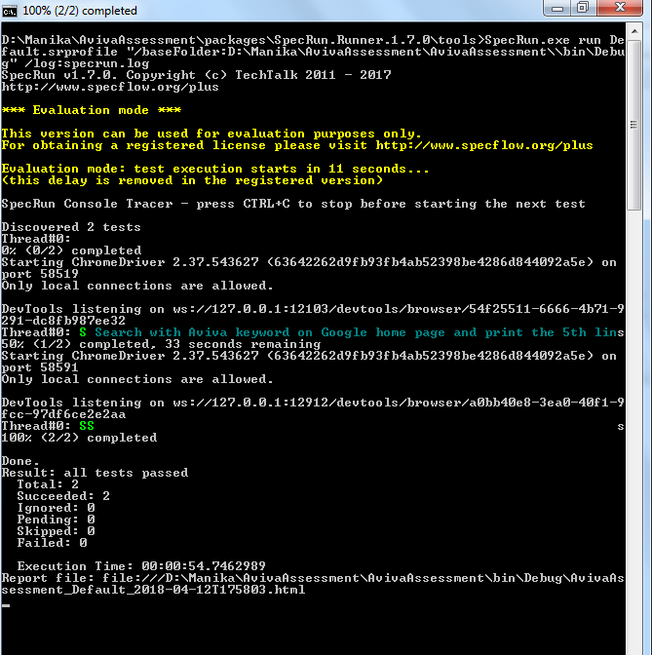

**Steps to Execute AvivaAssesment from Visual Studio IDE :**

1. **Extract Aviva Test Solution to a folder.**
2. **Click on AvivaAssessment.sln to launch project in visual studio in 2015 IDE.**
3. **Build Project and click on “RUN ALL” . This will launch execution of 2 scenario.**
4. **Execution reports can be found in output console. Specrun report will be generated.**

**Output Screenshot :**

